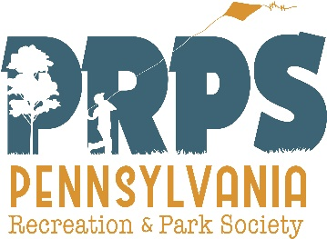
Recreation and Parks
Technical Assistant Program

(RecTAP) Grant Guidelines & Application

Purpose. RecTAP is a community recreation and parks consulting service coordinated by PRPS to provide management-related technical services of an experienced professional who has extensive training, knowledge and experience in the issues related to a proposed project.

Process. Prior to submitting a grant application, contact PRPS or the DCNR Regional Advisor for your location to discuss your proposed project, which must be of a reasonable size to complete within 6-12 months. If it is not, other grant sources may be recommended to better meet your planning needs.

Upon approval of the application, PRPS matches the organization’s request with an appropriate consultant, and enters into a three-way contractual agreement between the PRPS, the Organization, and the Consultant.

Upon completion, the consultant provides PRPS with a written report of recommendations addressing the problem or issues studied. Upon PRPS approval of the report, it is then submitted to the organization; PRPS issues the grant amount to the Consultant; and the organization submits an evaluation of the RecTAP program to PRPS.

Eligible Applicants. To be eligible to apply for RecTAP funding, organizations must be a group member of PRPS, or employs a staff person who holds a professional membership. In addition, the organization must be a unit of municipal government or a non-profit 501(c)(3) organization providing community recreation and park services. Organizations may receive only one RecTAP grant each calendar year.

Project Description. The grant application must include a project description that outlines the problem or issue that needs professional Consultant to study. No project budget is required for a RecTAP grant application. The reviewers will determine a fair amount up to a maximum of $2500, depending on the type of assistance required.

Project Selection. PRPS accepts complete RecTAP applications from eligible organizations at any time, and are evaluated with the following criteria:
- the clarity with which the service or “need” is expressed in the application
- the appropriateness of the requested services as they relate to improving the professionalism of the organization
- the degree to which the service will help to increase the capacity of the organization to improve its operations and provide better services to the public

Grant Availability. Grants up to a maximum of $2500 are available each year until the pool of funds is depleted. PRPS pays the grant amount directly to the Consultant upon a PRPS-approved completion of the project.

Types of Projects. Projects must be of a size to be completed within 6-12 months. Examples include:
- Recruiting, screening, and interviewing staff
- Getting started in providing recreation and park services
- Mission and vision statements
- Strategic planning
- Board training
- Budget and fiscal management
- Advantages of intergovernmental cooperation
- Partnership development
- Small concept site plans
- Cultural and diversity issues
- Greenways and trails
- ADA compliance
- Swimming pools
- Building public awareness
- Community centers
- Skate park facilities
- Program guide formats
- Organizational image
- Computer applications
- Volunteer management
- Marketing and public relations
- Recreation programming
- Citizen surveys
- Park planning and development
- Customer service audits
- Revenue sources
- Contracts and specifications
- Park and facility maintenance
- Policies and procedures
- Benefits of parks and recreation

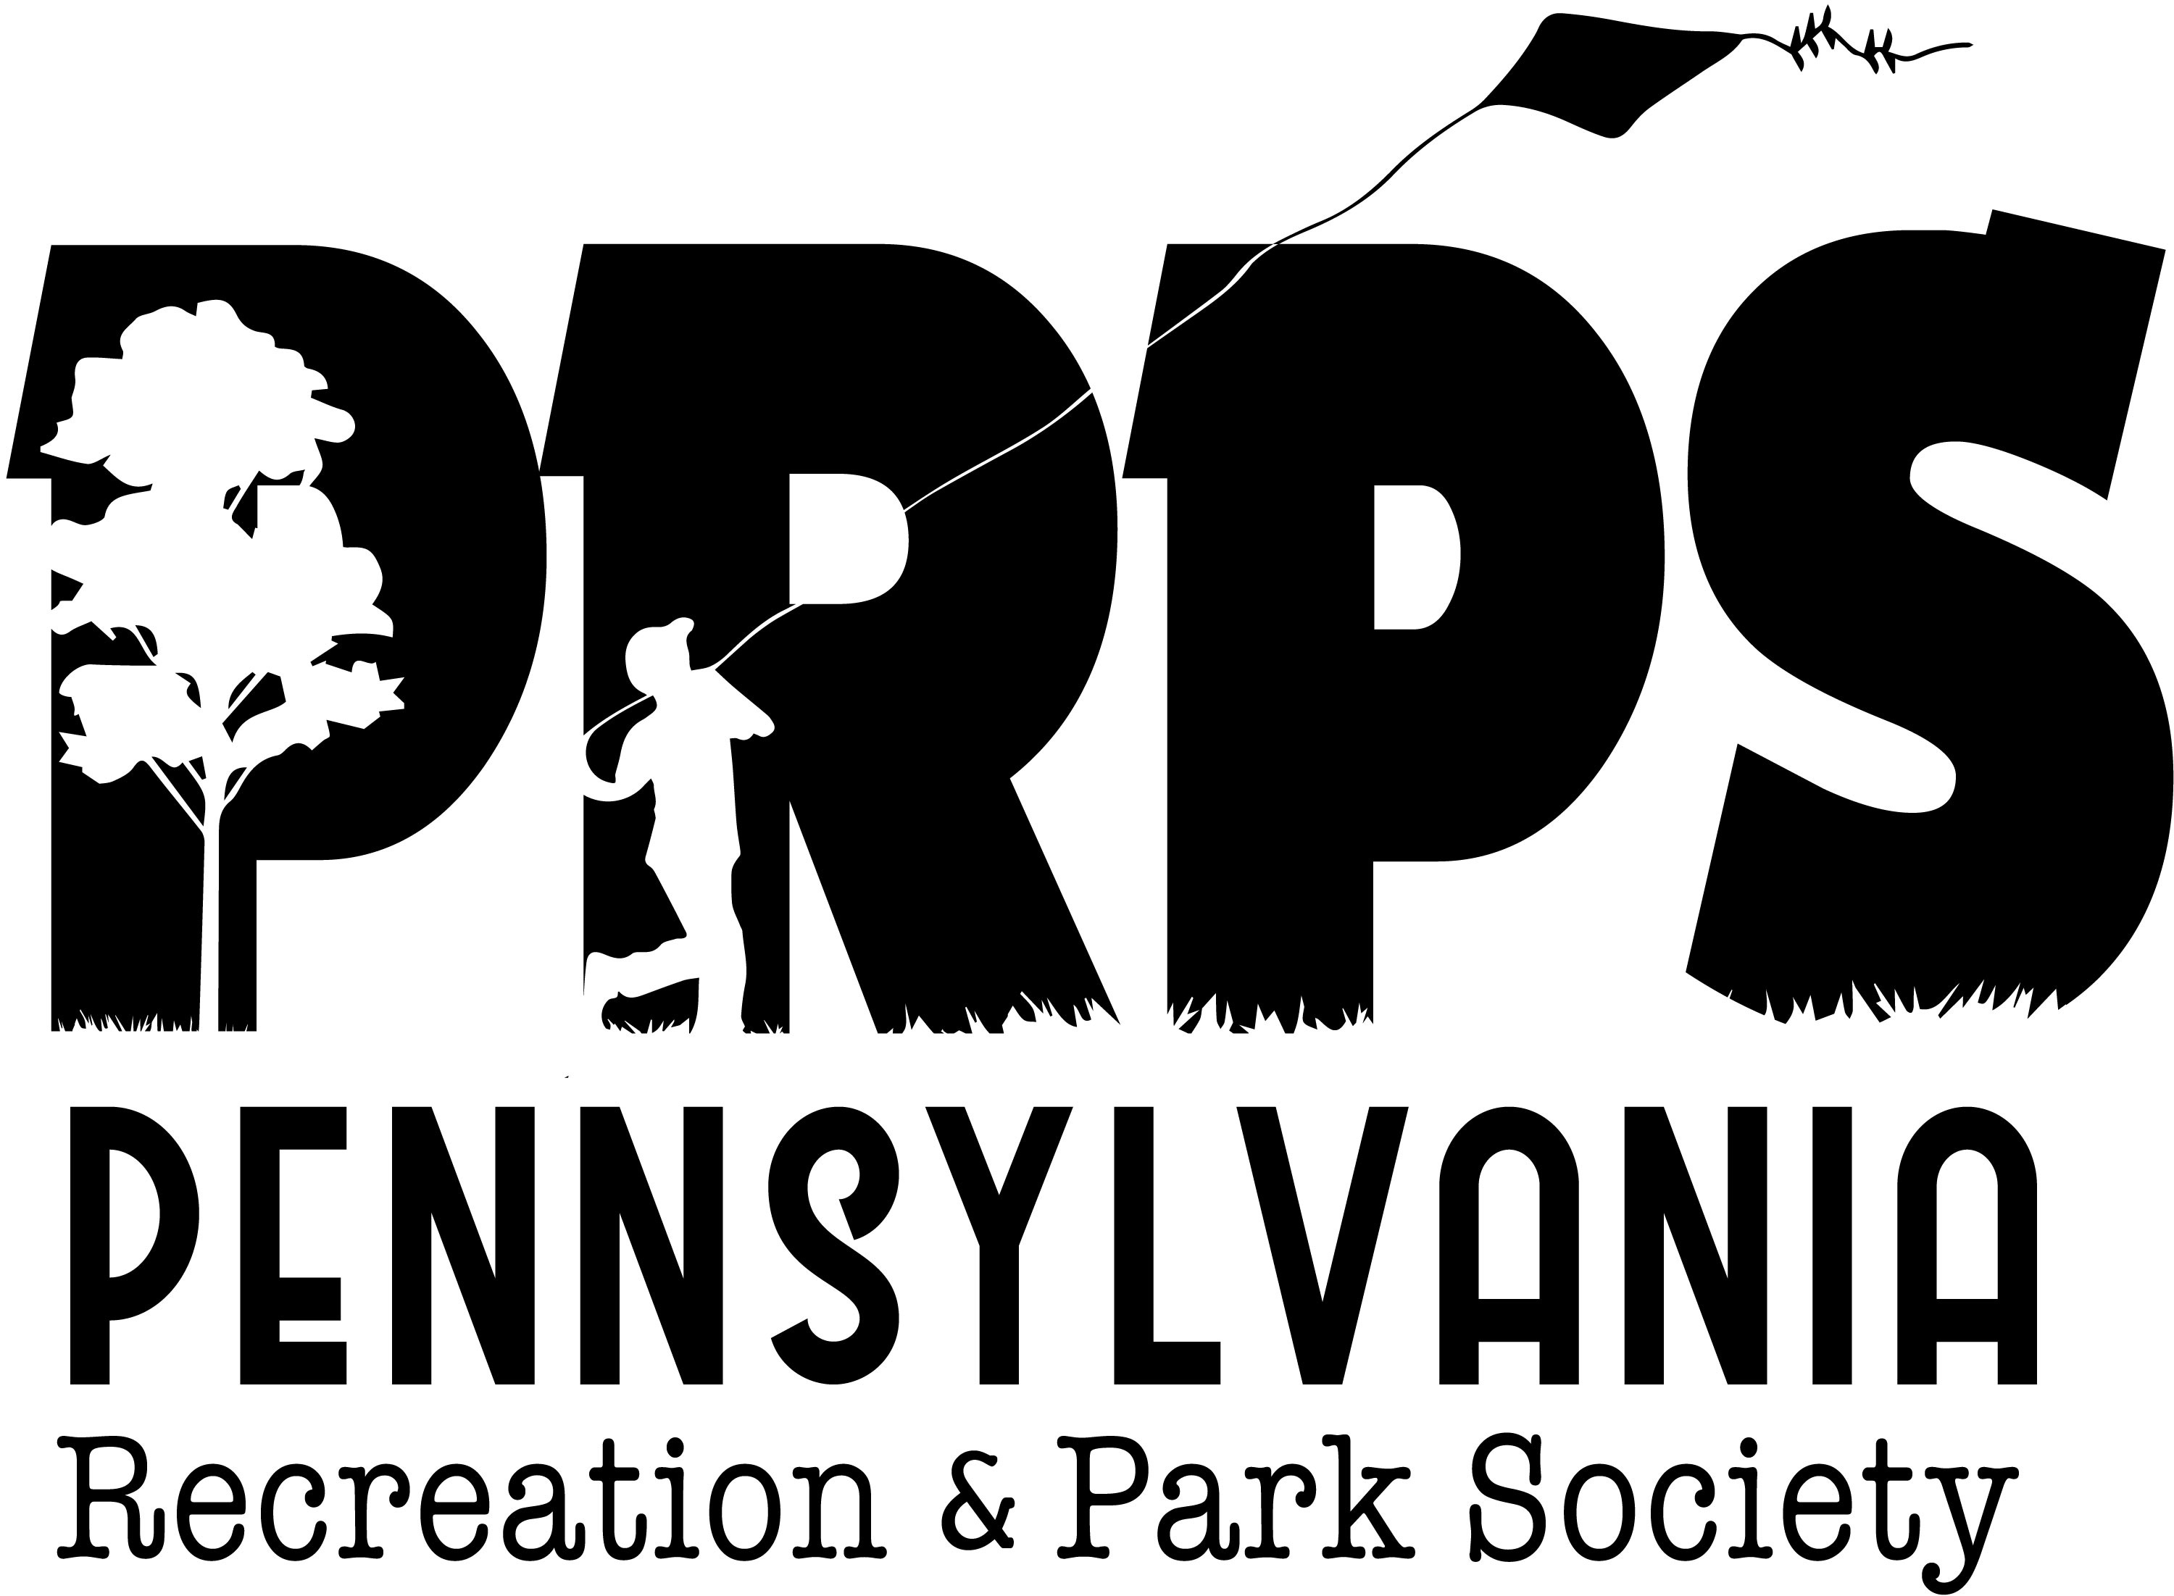
Recreation and Parks
Technical Assistant Program
Grant Application

Project Title: Submission Date:

Organization: County:

Eligible Type: Municipal Government Nonprofit (attach copy of IRS Letter of Determination)
Employer Identification Number: PRPS Membership:

Organization Address:

Phone: Website:

Organization Mission Statement:

Chief Executive Name: Title:
Phone: Email:

Application Contact Name: Title:
Address:
Phone: Email:

Project Summary (2-3 sentences)

Needs/Problem Statement: (½ - 1 page description of conditions, problems, issues and rationale why support should be provided.)

Desired Measurable Outcomes:

Suggested Consultant Recommendation and contact information (not required):

Requested Funding. RecTAP grants provide a maximum of $2500 in funding, which cannot serve as match to any open DCNR grant-funded projects: $

Certification: The applicant certifies to the Pennsylvania Recreation and Park Society that the information provided in this application and any attachments is true and correct. The applicant accepts in advance any grant awarded by PRPS by agreeing:
- That any such funds received as a result of the application will be expended under the grant contract.
- To other restrictions, conditions or changes PRPS may impose unless the applicant objects within 30 days of grant award agreement.
- To complete and return to PRPS an evaluation to help assess the effectiveness of the RecTAP Program.

Chief Executive Name_______________________________________ Title _____________________________

Signature____________________________________________ Date______________

RecTAP is administered by the Pennsylvania Recreation and Park Society and funded by a grant from the Community Conservation Partnerships Program, using the Environmental Stewardship Fund, under the administration of the Pennsylvania Department of Conservation and Natural Resources, Bureau of Recreation and Conservation.

